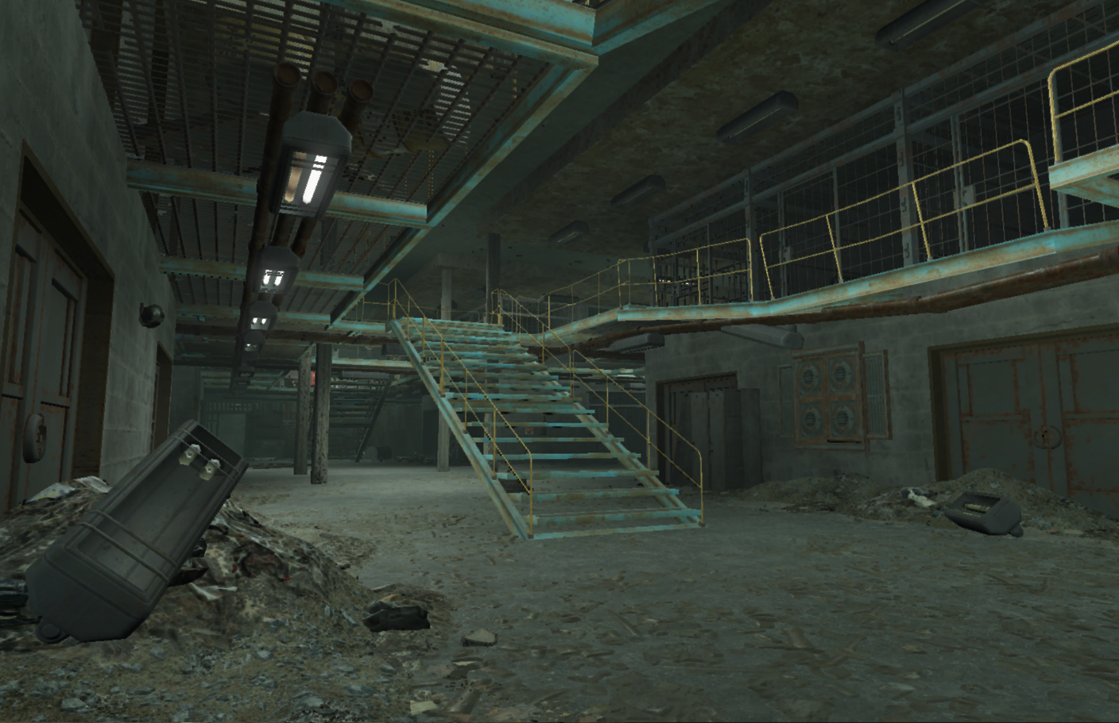

Fallout 4: An Emerging Plague

Version 3.0

|  |  |
| --- | --- |
| Designer: | William Bracho Blok |
| Document Date: | 4/9/2018 |
| Intended Level Delivery Date: | 4/9/2018 |

**Document Revisions Table**

|  |  |  |  |
| --- | --- | --- | --- |
| **Version** | **Description** | **Requestor** | **Date** |
| 1.0 | Initial Document | Professor | 2/23/2018 |
| 2.0 | Slightly modified quest story. Updated map layouts and added two extra maps. | Professor | 2/28/2018 |
| 3.0 | Refine quest story, updated maps, reference images and milestone schedule | Professor | 3/5/2018 |
| 4.0 | Refine quest story, updated maps and milestone goals | Professor | 4/9/2018 |
|  |  |  |  |

# Table of Contents

Table of Contents 2

Table of Figures 3

Level Information 4

Quick Summary 4

Level Maps 5

Map 1: Sewer 5

Map 2: Capybaras’ Parking Garage 7

Map 3: The Capybaras’ Lair – First Floor 9

Map 4: The Execution Room 10

Map 5: Capybaras’ Lair – 2nd Floor 11

Map 6: The Meeting Room (Capybaras’ Leaders) 12

Objective(s) 13

Hook(s)/Gameplay Highlights 13

Campaign 13

Context 13

Backstory 13

Aftermath 13

Development Schedule 14

Key Theme References 15

Visual Theme 1: Sewer 15

Visual Theme 2: Parking Garage 16

Visual Theme 3: The Capybaras’ Lair 17

Requirements 18

Appendix A: Quest Summary 19

Main Quest 19

References 20

# Table of Figures

Figure 1: Sewer 5

Figure 2: Capybaras’ Parking Garage 7

Figure 3: The Capybaras’ Lair 9

Figure 4: The Execution Room 11

Figure 5: The Meeting Room for the Capybaras’ Leaders 12

Figure 6: Contact Sheet for Visual Theme 1: Sewer 15

Figure 7: Contact Sheet for Visual Theme 2: Parking Garage 16

Figure 8: Contact Sheet for Visual Theme 3: The Capybaras' Lair 17

Level Design Document

# Level Information

## Quick Summary

An Emerging Plague is a single player standalone quest mod made for Fallout 4. In this quest, a small improvised criminal organization known as the Capybaras has emerged during the post-war era and have been seizing settlements near Sanctuary Hills to gain territory, resources, and power. A villager named Greg from one of these affected settlements has discovered the location of the Capybaras’ lair (an abandoned prison) and visited Sanctuary Hills to seek help from the player. Greg approaches the player and asks him/her to go to the Capybaras’ lair to kill their leaders in hopes of dissolving their criminal organization. Once the player arrives to the Capybaras’ lair, (s)he stumbles upon a prisoner named Leo, who was captured by the criminal organization. Leo begs the player for help and tells the player where the leaders of the Capybara are and that they are about to go out on their next trip to seize another settlement. Leo also begs the player to rescue him and his wife Matilda, who is being tortured to death somewhere nearby and is about to die. The player relates his/her story with the prisoner’s situation and is willing to help. However, Matilda and the leaders of the Capybaras are on opposite ends of the facility, and there is not enough time to kill the leaders of the Capybaras and rescue Matilda, so the player must decide whether to rescue Matilda or kill the leaders of the Capybaras before they go on their next raid and kill more villagers.

## Level Maps

### Map 1: Sewer

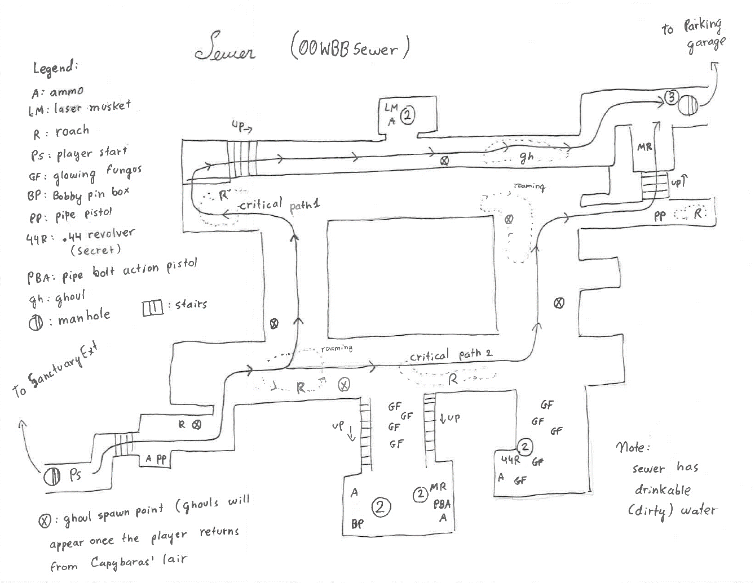

Figure 1: Sewer

|  |  |  |  |  |  |
| --- | --- | --- | --- | --- | --- |
| Map Label | Event Description | Detail Information | Approx. Difficulty (1-10) | Approx. Time | Wow? |
| None | The player finds an entrance to the sewer (off-map) | The player searches and finds an entrance to a sewer near Sanctuary hills based on Greg’s directions. (off-map). | 1 | 3 mins | N |
| 2 | (Optional) the player collects useful items such as weapons, ammo, and bobby pins | (Optional) the player searches through the sewer to collect useful items such as weapons, ammo, and bobby pins. The player will also encounter minor threats such as rats and roaches roaming the area. | 2 | 3 mins | N |
| 3 | The player finds an entrance to the Capybaras’ parking garage. | The player searches through the sewer to find a ladder to a manhole that leads to the Capybaras’ underground parking garage (map label 3 on figure 1). The player will also encounter minor threads such as rats and roaches roaming the area. | 1 | 2 min | N |

### Map 2: Capybaras’ Parking Garage

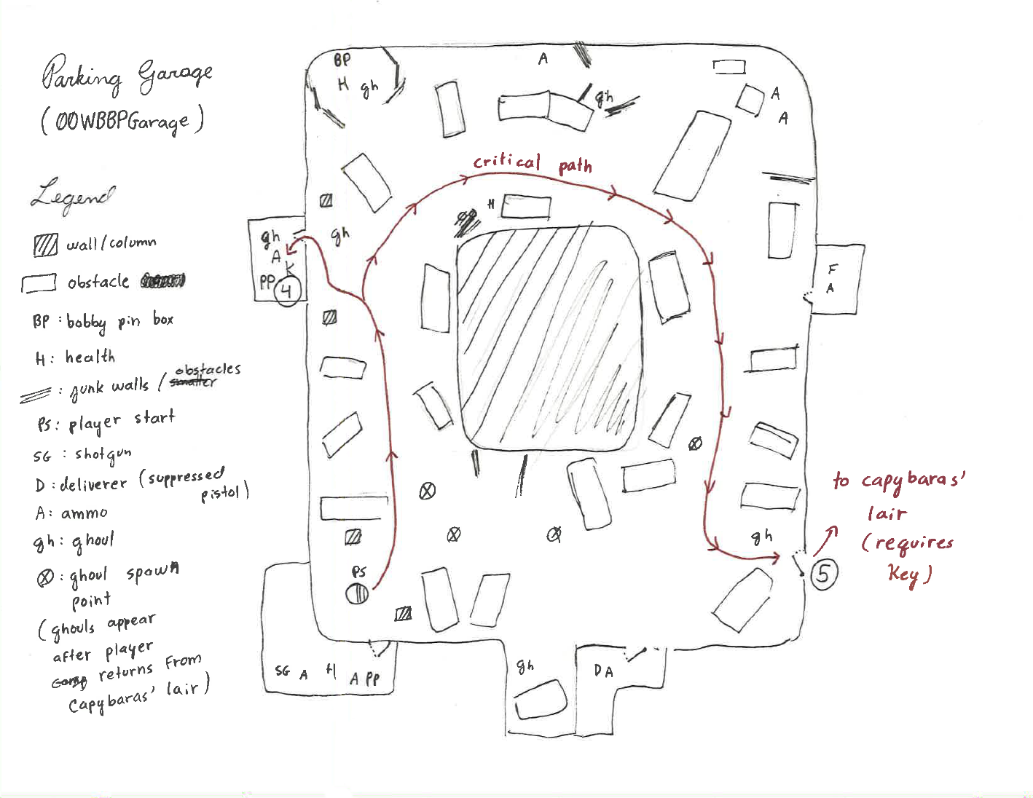

Figure 2: Capybaras’ Parking Garage

|  |  |  |  |  |  |
| --- | --- | --- | --- | --- | --- |
| Map Label | Event Description | Detail Information | Approx. Difficulty (1-10) | Approx. Time | Wow? |
| 4 | The player finds a key that unlocks an entrance to the Capybaras’ lair | The player searches through an abandoned underground parking garage to find a key (label 4 on figure 2) that unlocks a door leading to the Capybaras’ lair (label 5 on figure 2). The player will also encounter feral ghouls roaming around the area, but he/she will be able to seek cover to avoid fighting all of them at once. | 3 | 2 mins | N |
| 5 | The player finds and unlocks the entrance to the Capybaras’ lair | The player searches through the parking garage to find the door that leads to an entrance to the Capybaras’ lair. The player will also encounter feral ghouls roaming the area | 3 | 3 mins | N |

### Map 3: The Capybaras’ Lair – First Floor

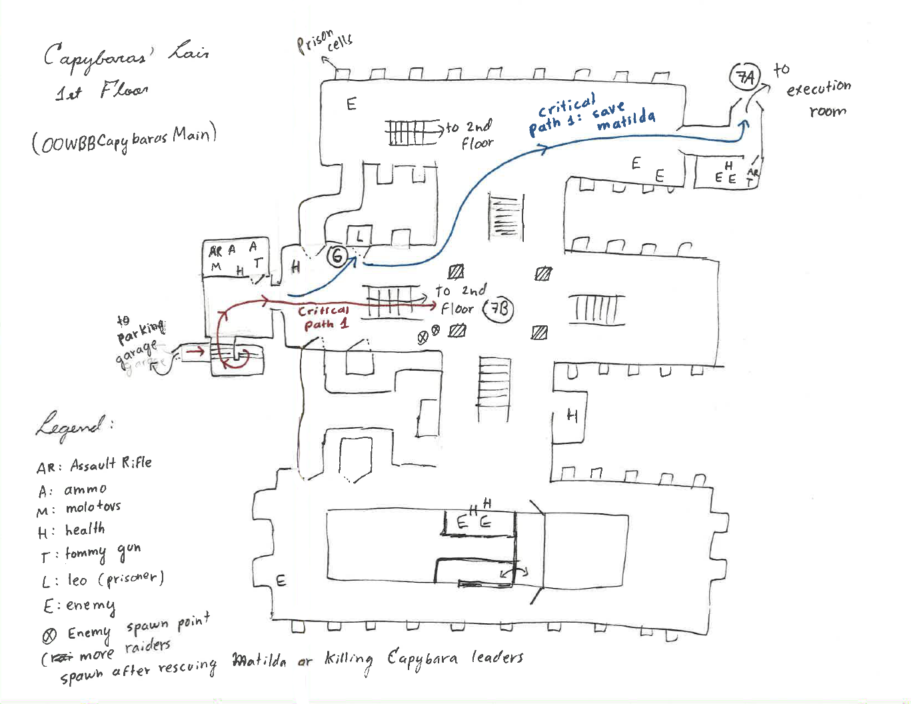

Figure 3: The Capybaras’ Lair

|  |  |  |  |  |  |
| --- | --- | --- | --- | --- | --- |
| Map Label | Event Description | Detail Information | Approx. Difficulty (1-10) | Approx. Time | Wow? |
| 6 | (optional) The player finds Leo | The player finds a prisoner named Leo, who begs the player to rescue him and his wife. Leo also tells the player where the leaders of the Capybara are | 1 | <1 min | Y |
| 7a | The player goes to rescue Matilda | The player goes to the execution room where Matilda is being tortured. The player will also encounter some guards on the way. | 4 | 3 min | Y |
| 7b | The player goes upstairs to find the room where the leaders of the Capybara are | The player goes upstairs to find the room where the leaders of the Capybara gang are. The player will also encounter some guards on the way. | 6 | 3 mins | Y |

### Map 4: The Execution Room

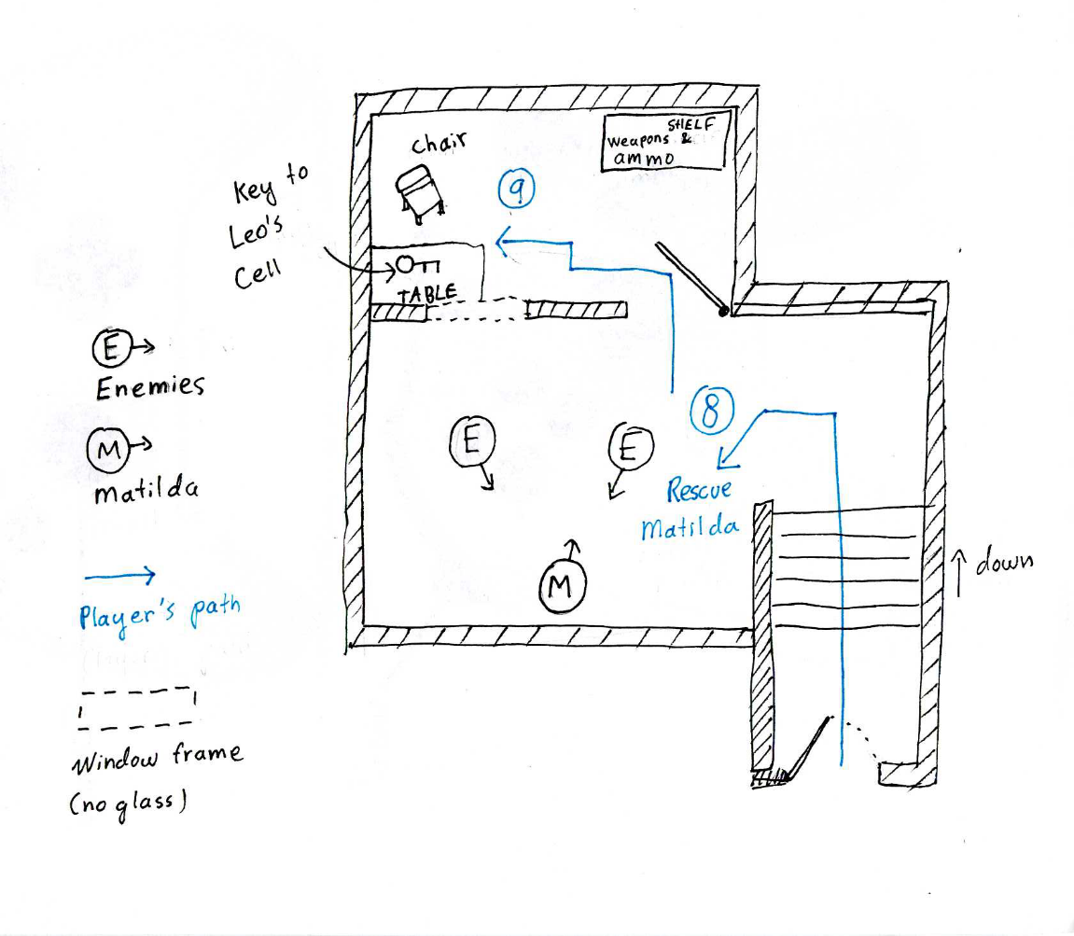

Figure 4: The Execution Room – where Matilda is being held

|  |  |  |  |  |  |
| --- | --- | --- | --- | --- | --- |
| Map Label | Event Description | Detail Information | Approx. Difficulty (1-10) | Approx. Time | Wow? |
| 8 | The player kills the guards in the execution room to save Matilda. | The player reaches the execution room and kills the guards on the area to save Matilda. Matilda says that the key to Leo’s cell is somewhere in this room. At this time, the leaders of the gang already left the facility to take in their next raid. | 4 | <1 min | Y |
| 9 | The player collects the key to Leo’s cell | The player collects the key to Leo’s cell |  |  |  |
| 6 | The player goes back to rescue Leo. Matilda starts following the player. | The player goes back to rescue Leo. Matilda starts to follow the player. The player and Matilda will encounter more guards who came for backup. | 3 | 4 min | N |
|  | The player escorts Leo and Matilda to Sanctuary Hills | The player escapes with Matilda and Leo by taking the same route as the player used to infiltrate in. There will be new enemies on the way. Once the player reaches Sanctuary Hills with Matilda and Leo, both thank the player and join the player’s faction; they become settlers of Sanctuary Hills. | 4 | 6 min | Y |

### Map 5: Capybaras’ Lair – 2nd Floor

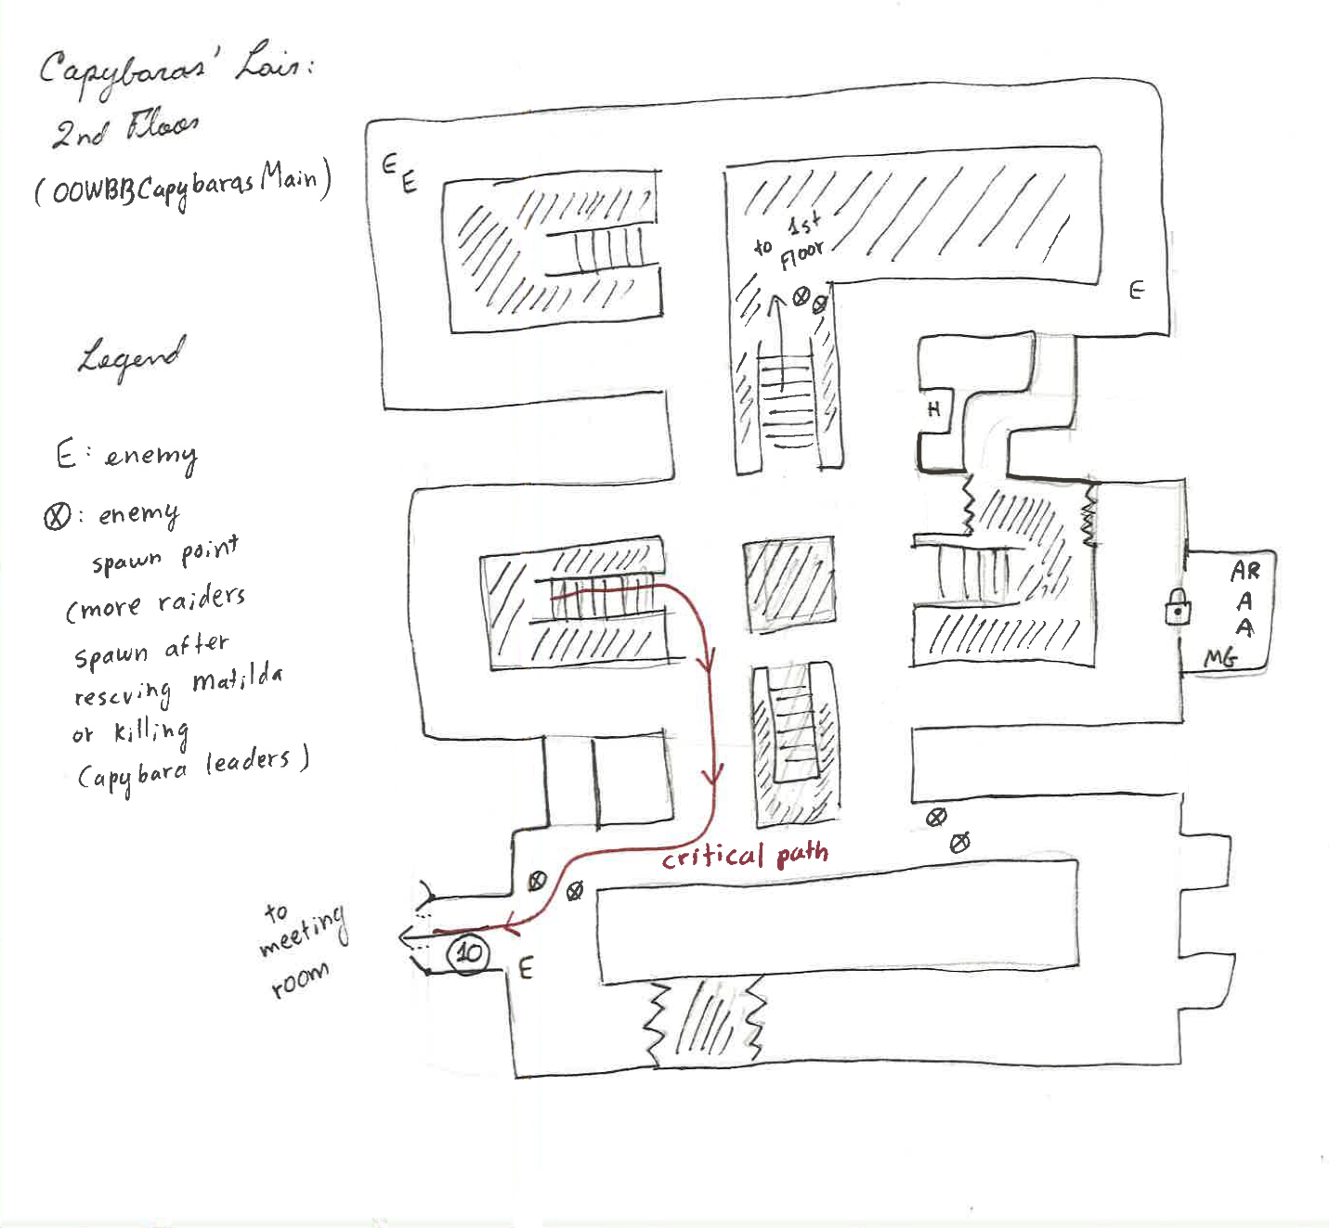

Figure 5: Capybaras’ Lair – 2nd Floor

|  |  |  |  |  |  |
| --- | --- | --- | --- | --- | --- |
| Map Label | Event Description | Detail Information | Approx. Difficulty (1-10) | Approx. Time | Wow? |
| 10 | The player finds the entrance to the room where the leaders of the Capybara are. | The player finds the entrance to the room where the leaders of the Capybara are. The player will also encounter some guards on the way. | 5 | 3 min | Y |

### Map 6: The Meeting Room (Capybaras’ Leaders)

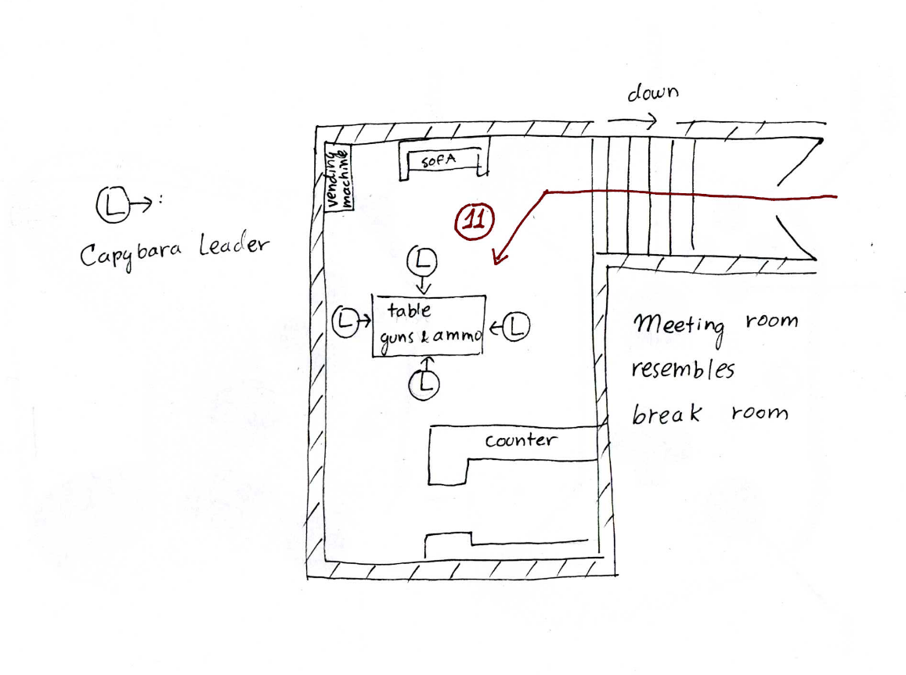

Figure 6: The Meeting Room – location of the Capybara leaders

|  |  |  |  |  |  |
| --- | --- | --- | --- | --- | --- |
| Map Label | Event Description | Detail Information | Approx. Difficulty (1-10) | Approx. Time | Wow? |
| 11 | The player kills the leaders of the Capybara gang. Matilda is executed. | The player kills the leaders of the Capybara gang. At this point, both Matilda and Leo are executed. | 4 | <1 min | Y |
| None | The player leaves the Capybaras’ lair**.** | The player leaves the Capybaras’ lair by taking the same route the player used to infiltrate in. The player will also encounter more guards who came for backup and additional ghouls on the parking garage and sewers. | 3 | 5 min | N |

## Objective(s)

* Gain entrance to the Capybaras’ lair
  + Find the sewer and the underground parking garage that leads to the Capybaras’ lair
* Meet with Leo to gain knowledge about the current location of the Capybaras’ leaders and Matilda
* Either:
  + Kill the Capybaras’ leader
  + Or rescue Matilda and Leo
* Report back to Greg.

## Hook(s)/Gameplay Highlights

* This quest is available right after the player emerges from the vault and reaches Sanctuary Hills
* The player must make a difficult choice during the quest – either rescue Matilda and Leo (a situation in which the player can relate to) or kill the leaders of the Capybara gang and let the couple die.
* The quest provides a 10mm suppressed pistol (and ammo scattered around) which the player can use to kill enemies stealthily
* The name of the Capybara gang

## Campaign

### Context

An Emerging Plague is a standalone quest set near Sanctuary Hills that is available right after the player emerges from the vault. It can be played at any skill level. This quest is independent of the story of Fallout 4 base game and does not require to have any other quest to be completed.

### Backstory

* The Capybaras are a small and improvised criminal organization that emerged during the post-war to seek power and take over resources. Some of the common traits that identify this gang includes the heavy leather jacket that they all wear and tattoo marks on their faces. Oftentimes, Capybara gangsters capture and kill civilians to eat them due to food scarcity.
* Matilda killed one of the Capybara gang and attempted to escape with Leo. Unfortunately, both were recaptured, and Matilda was sent to be tortured to death. Leo attempted to escape again and rescue Matilda, but he got locked in one of the prison’s cell

### Aftermath

Ending 1 – The player rescues Leo and Matilda: Matilda and Greg thank the player and settles somewhere in Sanctuary Hills. They join the player’s neighborhood and faction. The player rendezvouses with Greg, and Greg is upset and nervous to hear that the leaders of the Capybara gang are still alive and seizing more settlements. However, he respects the player’s choice and acknowledges that it was a hard decision to make. Greg hopes that one day the Capybara gangsters are annihilated by other organization such as the Brotherhood of Steel or by super mutants, but until then the fate of Sanctuary Hills’ neighboring settlements is still in jeopardy. Greg does not reward the player and walks away.

Ending 2 (where the player kills the leaders of the Capybaras): the player rendezvouses with Greg. Greg thanks and rewards the player for saving his village and eradicating this plague. However, Greg is deeply saddened to hear the story of Matilda and Leo; though he understands that it was a hard decision to make and that it was in the best interest of the neighboring communities. Greg joins the player’s neighborhood and faction

## Development Schedule

|  |  |
| --- | --- |
| Milestone | Date |
| LDD | 3/5/2018 |
| Basic environment setup: have 5 placeholder environments connected | 3/6/2018 |
| Basic NPC setup – Greg | 3/7/2018 |
| Basic NPC setup - Capybara leaders | 3/9/2018 |
| Basic kill quest setup - to kill the leaders of the Capybara gang. Implement very basic dialog | 3/11/2018 |
| Basic NPC setup – prisoner | 3/12/2018 |
| Basic NPC setup: Prisoner’s wife – NPC that can follow the player | 3/14/2018 |
| Set up rescue quest – to rescue the prisoner’s wife. Implement very basic dialog | 3/16/2018 |
| Connect kill quest with rescue quest and playtest. | 3/17/2018 |
| Basic NPC setup – generic capybara gangsters | 3/19/2018 |
| First pass environment scale and layout – Including locked doors and the key to Capybara’s lair | 3/20/2018 |
| Whitebox with firs pass enemy placement (rats, ghouls, capybara gangsters) and first pass dialog | 3/21/2018 |
| Quest feature: have Greg appear and approach the player and ask for help (instead of having him stand still). | 3/25/2018 |
| Quest feature: enemies patrolling an area and having idle animations (for guards and ghouls) | 4/2/2018 |
| Refine dialogs | 4/6/2018 |
| Gameplay – have all gameplay elements done | 4/9/2018 |
| Second pass environment – adding basic decoration | 4/13/2018 |
| First pass lighting | 4/17/2018 |
| Second pass lighting | 4/21/2018 |
| Aesthetics – finalize all decoration and lighting | 4/25/2018 |
| Finalize dialogs | 4/28/2018 |
| Quest feature: have Greg walk out or join the player’s faction (depending on quests outcome) | 5/2/2018 |
| Quest feature: have Leo and Matilda join the player’s faction if rescued | 5/5/2018 |
| RTM | 5/7/2018 |

## Key Theme References

### ­Visual Theme 1: Sewer

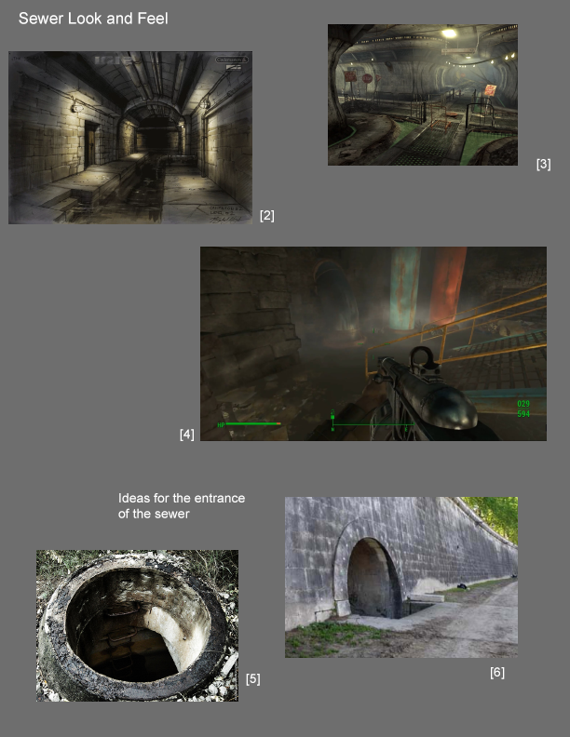

Figure 7: Contact Sheet for Visual Theme 1: Sewer

### Visual Theme 2: Parking Garage

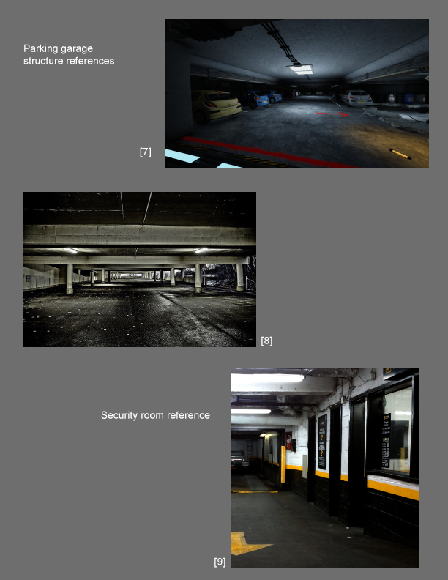

Figure 8: Contact Sheet for Visual Theme 2: Parking Garage

### Visual Theme 3: The Capybaras’ Lair

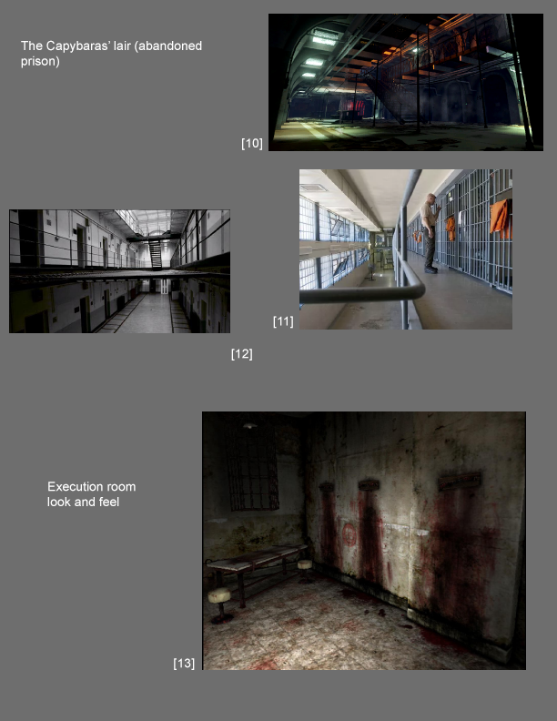

Figure 9: Contact Sheet for Visual Theme 3: The Capybaras' Lair

## Requirements

|  |  |  |  |
| --- | --- | --- | --- |
| Map Label | Description | Type | Priority |
| Off map | An initial quest giver with dialog taking the role of Greg | NPC | High |
| 6 | A non-playable character with dialog taking the role of Leo | NPC | High |
| 4 | Keys for the Capybaras’ lair entrance. | Items | High |
| 8 | An NPC for Matilda | NPC | High |
| E | A few generic NPC templates for the Capybaras guards: one with a machine gun, and another with a pistol | NPC | Medium |
| 10 | A few NPC templates for the leaders of the Capybaras | NPC | Medium |
|  |  |  |  |

# Appendix A: Quest Summary

## Main Quest

1. Greg, a villager from a neighboring settlement being attacked by the Capybara gang arrives at Sanctuary Hills and approaches the player to ask for help. Greg asks the player to eliminate the Capybara leaders for a reward. Once the player accepts Greg’s quest, Greg gives directions to the player on how to infiltrate into the Capybaras’ lair, which consists on going through a sewer that leads to an underground parking garage, which contains a door to the Capybaras’ lair.
2. The player enters a sewer near the Capybaras’ lair and searches for a way to get into the parking garage adjacent to the Capybaras’ lair. The player may find useful items such as bobby pins, weapons and ammo. The player will also encounter small threats such as aggressive rats and mutant roaches roaming the area.
3. The player enters to the parking garage adjacent to the Capybaras’ lair through a manhole. In this area, the player looks for a key to open a door that leads into the Capybaras’ lair. The security room in this area has a suppressed pistol with some ammunition that the player can use to fight enemies, but it will require to be lock-picked to enter (novice-level lock). The player will encounter some ghouls roaming around, so precaution must be taken to go through the area.
4. Once the player infiltrates into the Capybaras’ lair, the player finds Leo, who begs the player for help and tells the player the current location of the Capybaras’ leaders. However, the Matilda and the leaders of the Capybaras are on opposite ends of the facility, and there is not enough time to kill the leaders of the Capybaras and rescue both Greg and Matilda, so the player must decide whether to rescue Matilda or kill the leaders of the Capybaras before they go on their next raid.
5. **Choice 1: rescue Leo and Matilda:** the player goes to the execution room and kills the guards that are about to execute Matilda. The player then recues Leo and escort both Matilda and Leo out of the facility by taking the same route the player used to infiltrate in and fights any enemies encountered on the way.
6. **Choice 2: kill the leaders of the Capybaras:** the player goes to the room where the leaders of the Capybaras are and kills them. The player then proceeds to exit the facility by taking the same route (s)he used to infiltrate to the facility.
7. **Ending 1:** the player reaches Sanctuary Hills with Matilda and Leo; they thank the player for rescuing them, and they join the player’s faction. The player reports back to Greg and tells him that he could not stop the Capybaras’ leaders as they went out on their next raid.
8. **Ending 2:** the player reports back to Greg to announce that the leaders of the Capybaras are dead, and Greg is happy to hear this news, so he rewards the player and joins the player’s faction.

## References

[2] <https://vignette.wikia.nocookie.net/igi/images/a/aa/Art_sewers.gif/revision/latest?cb=20090214035140>

[3] <https://vignette.wikia.nocookie.net/fallout/images/f/fc/County_sewer_mainline.jpg/revision/latest?cb=20110619205956>

[4] <https://i.ytimg.com/vi/OQt9Df3HBuY/maxresdefault.jpg>

[5] <http://cdn.obsidianportal.com/assets/191138/underground_entrance.jpg>

[6] <http://www.tideandcurrenttaxi.org/wp-content/uploads/2009/05/imgp1544.jpg>

[7] <http://files.gamebanana.com/img/ss/maps/55da7168c3366.jpg>

[8] <https://www.urbanghostsmedia.com/wp-content/uploads/2016/06/inside-an-abandoned-parking-lot-in-Stockholm-2.jpg>

[9] <http://www.automobiliac.com/storage/IMAG0200.jpg?__SQUARESPACE_CACHEVERSION=1300731371254>

[10] <https://wiki.tripwireinteractive.com/images/f/fb/KF2_Map_Prison.png>

[11] <https://www.gannett-cdn.com/-mm-/639449c565da8c898d74aef917750e6c237d60c1/c=256-0-1972-1290&r=x404&c=534x401/local/-/media/2017/01/13/Phoenix/Phoenix/636199301327097673-PNIBrd2-01-29-2016-Republic-1-A005--2016-01-28-IMG-Arizona-State-Prison-1-1-9GDA1GOT-L751817242-IMG-Arizona-State-Prison-1-1-9GDA1GOT.jpg>

[12] <https://brightcove04pmdo-a.akamaihd.net/4221396001/4221396001_5593005624001_5583019604001-vs.jpg?pubId=4221396001&videoId=5583019604001>

[13] <https://orig00.deviantart.net/777d/f/2011/104/3/0/silent_hill_torture_room_by_parrafahell-d3e01li.jpg>